

Large Move in the Gold stocks Imminent?

By Adrian Douglas

There is much concern among investors with respect to the performance of mining equities. There is a view that, in general, mining equities have been poor performers. However, one has to distinguish between mining companies that are aggressively acquiring mineral resources and exploration companies that are in the early stages of mineral exploration. It has only been the mining companies that have seen large gains in the value of their stocks.

The performance of these mining companies overall have been excellent. From 2001 to 2009 the mining equities notched up a gain of a stunning 12.5 times, with respect to the HUI (index of un-hedged miners). In 2008, despite the HUI falling below 200, it has recently regained new highs just below 600. If someone had bought the HUI at its low in 2001, and held it until today, it would have returned 15 fold despite the damage wreaked in 2008. This has to be compared with a return on gold of seven times over the same period. It must be admitted that Junior Exploration stocks have not participated in the same gains as mining equities who have established resources in the ground.

In the figure below, the red line represents the price of gold while the blue line represents the value of the HUI. It can be seen that the HUI is stalling out at approximately the 600 level.

Given the stalling of the HUI, could one be justified in believing that the HUI has reached its potential, as indicated by the dotted blue line? We believe this is not the case and the strongest argument for this is the latest quantitative easing newly announced. This could well blast mining equities to new levels and is the likely trajectory of the mining stocks, demonstrated by the blue arrow.

Mining shares give large leverage to gold prices due mainly to acquisition and the devaluation of the currency.
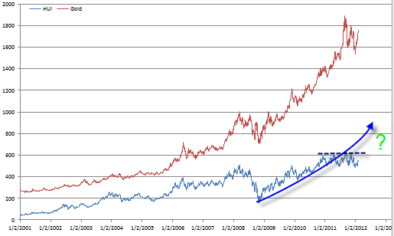

The growth in the value of the mining equities has not been mirrored in the Junior exploration sector. We expect this to change when new real growth over takes consolidation. The Seniors desperately need new resources which will bring in new funds and will drive new exploration. This is where the biggest gains can be made if appropriate due diligence is performed to choose Junior Exploration companies that have good chances of finding significant new resources in the ground. The potential to turn a Junior Explorer into a company with significant resources could multiply the stock value as much as 100 times.

The very large gains in precious metals over the last 10 years are finally translating into a scramble to secure resources from much smaller companies. It should be noted that this is essentially consolidation of resources from the smaller to the larger miners. The only way that significant resources can be added is to develop organic growth. This will be the next phase of the precious metals bull market as new equity pours into miners providing them with a flood of new capital that will seek out opportunities to grow the desperate need to increase precious metals.

Fortunes will be made in the coming frenzy as investors scramble to seek out scarce resources.

Adrian Douglas
Editor of Market Force Analysis
Board Member of GATA

February 12, 2012

www.marketforceanalysis.com
Market Force Analysis is a unique analysis method which provides reliable indications of market turning points and when is a good time to enter, take some profits or exit a market. Subscribers receive bi-weekly bulletins on the markets to which they subscribe as well as email alerts and updates.
SPECIAL OFFER
For a short period only get one month free trial subscription by sending an email to: info@marketforceanalysis.com with title of “free trial”.

