

Deflation – Nowhere to be Seen

By Adrian Douglas

There are frequent claims that the U.S. economy has entered a period of “deflation.” These claims are totally unfounded and are false. Deflation can only be a persistent state of general price decline. In fact, in examining price trends, the U.S. is experiencing shocking price increases of over 15% per annum. To illustrate this, Figure 1 shows the Continuous Commodities Index, CCI over the past ten years.

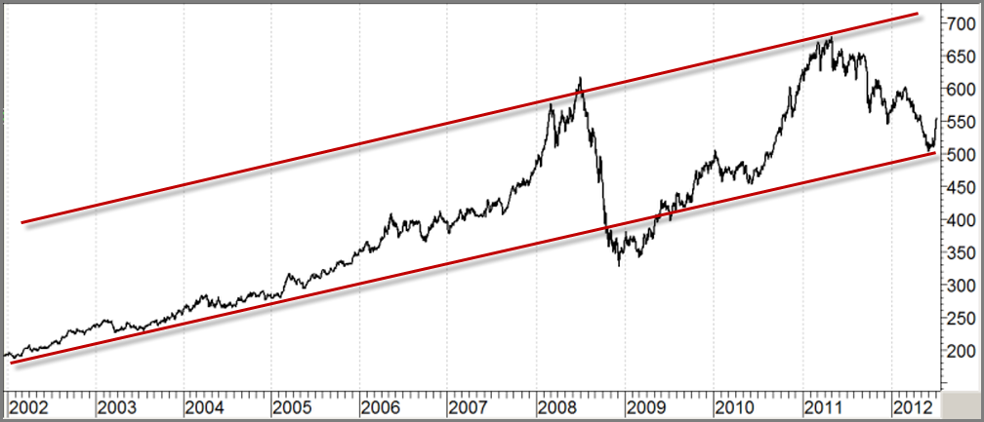
Figure 1: Continuous Commodities Index (CCI) 2002-2012

The CCI shows there are periods of high inflation and brief periods of “disinflation”. “Disinflation” is a period when the money supply expansion slows but does not contract. An analogy of this is a car that can speed up or slow down but does not stop. When the car accelerates it is analogous to inflation, while the car slowing down is analogous to “disinflation.” Conversely, “deflation” would mean that the car stops and reverses. There is absolutely no sign of any reversal in the general trend of inflation.

The CCI is an index of 17 different commodities namely: Cocoa, Coffee ‘C’, Copper, Corn, Cotton, Crude Oil, Gold, Heating Oil, Live Cattle, Live Hogs, Natural Gas, Orange Juice, Platinum, Silver, Soybeans, Sugar No. 11, and Wheat. The index covers a broad range of industrial raw materials for the production of energy, food, metals, and textiles. The CCI composition remains unchanged since 1995 and so suffers no hedonistic massaging or adjustments unlike the government produced Consumer Price Index, CPI, and Producer Price Index, PPI.

The index is equally weighted so it is the geometric mean of these 17 commodity prices. This means that the price of the CCI cannot spike due to an increase in price of just one or two commodities. For the index to rise 10% all 17 components would need to rise 10% or one component would have to rise 500%. If oil were to rise tomorrow to $400/bbl and all other 16 components did not change in price, the index would only rise by 10%. This means that the CCI is a stable indicator of price trends.

What can be seen from figure 1 is that the CCI has been in a rising trend for ten years as shown by the solid red channel.

The financial crisis has caused a massive increase in money supply coined, “Quantitative Easing.” This has led to relatively more money chasing fewer goods and services; a textbook definition of inflation. The U.S. has financed two wars in the past ten years, costing trillions of dollars. Instead of exercising fiscal discipline to pay for their foreign misadventures, money has been printed at alarming rates. The parallels of the US economy with that of Weimar Germany are eerie. The post-war economy was in ruins. They were saddled with huge debt in the form of war reparation obligation payments. In order to meet the gap between tax receipts and expenditure they printed money. The main concern at the time for the global economy was a fear of deflation. This turned out to be totally misguided. Instead, the monetary destruction was fast. It took only 12 months to transition from mild inflation to high inflation and then a further 16 months to ramp up to total hyperinflationary destruction of the currency.

There has been no true occurrence of “deflation” in the last 77 years. Deflationists point to Japan as an example but it is more accurately defined as “disinflation” rather than deflation because Japan’s money supply has never contracted; its rate of expansion slowed and reached the zero level for a while.

Regarding the U.S., Figure 1 shows the trend in “disinflation” has now started its reversal to inflation and so, a period of high inflation is resuming. It is short periods of “disinflation” that have the media and commentators erroneously claiming deflation. As the period of inflation accelerates, it is an excellent time for investors to add to or commence their long positions in precious metals.

Owning physical allocated gold and silver is the time honored protection of wealth from the destructive ravages of inflation and hyperinflation. The CCI demonstrates unequivocally that inflation is consistently destroying your wealth. The current dip in the prices of gold and silver provides an excellent opportunity to buy.

Adrian Douglas
Editor of Market Force Analysis
Board Member of GATA

July 7, 2012

www.marketforceanalysis.com

