Gold Market is not “Fixed”, it’s Rigged

By Adrian Douglas

In 1919 the major London gold dealers decided to get together in the offices of N.M. Rothschild to “fix” the price of gold each day. While this was notionally to find the clearing price at which all buying interest and all selling interest balanced the possibility for market manipulation and self-dealing is inherently systemic in such a cozy arrangement. This quaint anti-competitive procedure continues to this day. In no other market in the world do the major players get together each day and decide on a price. Imagine if Intel, AMD and Samsung were to meet each day to “fix” the price of microchips, or if the major oil companies were to meet each day to “fix” the price of crude oil; wouldn’t there be a public outcry and a flurry of antitrust violation lawsuits? The “fix’ is not open to the public, there are no published transcripts of each fixing, and there is no way to know what the representatives of the bullion banks discuss between each other.

The current London Gold Fix is conducted by the representatives of five bullion banks, namely HSBC, Deutsche Bank, Scotia Mocatta, Societe Generale, and Barclays. The “fix” is no longer conducted in an actual meeting but by conference call.

The London Gold Pool that was instigated in the 1960’s was incontestably established with the sole purpose of suppressing the gold price. Several central banks furnished gold to sell into the market with the aim of keeping the gold price at $35/oz. This was overt market manipulation. How was this achieved? The internet site www.goldfixing.com explains here as a historical fact that “1961 - Gold Pool of US and main European central banks set up to defend $35 price, by selling at fixing to contain it”. So the London Gold Pool sold into the “fix” to suppress the price and no doubt the bullion bankers making the “fix” were party to this scheme.

The London Gold Pool disbanded in 1968 when it suffered massive outflows of bullion trying to frustrate free market forces that were manifesting themselves as insatiable demand for the metal.

As there is no London Gold Pool anymore does this mean that this mechanism of selling into the fix to suppress the gold price, that was pioneered by the London Gold Pool, is defunct also? Absolutely not! Analysis of the gold price data shows quite clearly that the price of gold is being heavily suppressed by the exact same mechanism.

Fortunately the bullion bankers added the AM Fix in 1968. This means there are two times in the day when we know for sure that the gold price is being set in a clandestine procedure that is controlled by just five bullion banks.

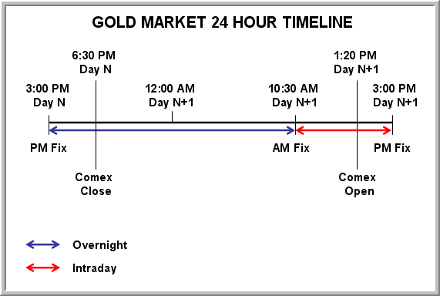
Figure 1 Gold Market Timeline

We will examine the characteristics of the prices determined by the London Daily Gold Fixings to demonstrate unequivocally the gold price is suppressed. To do this let’s examine what happens in a typical twenty-four hour period as illustrated in figure 1. We have chosen to start and end the 24 hour period with the PM Fix. Three and a half hours after the PM Fix the Comex closes and gold trading is then predominantly conducted in the eastern hemisphere where the western bullion banks have much less influence and the market has a much higher proportion of physical metal trading than does London or the Comex. The period from the PM Fix to the following AM Fix is labeled “overnight” trading (indicated by the blue double-headed arrow). The period from the AM Fix to the PM Fix has been labeled “intraday” trading (indicated by the red double-headed arrow). The intraday trading includes most of the trading day on the LBMA where 90% of the world’s gold trading occurs. It would be fair to say that this is the time of the day most influenced by the western cartel of gold bullion banks. The “overnight” trading is the least influenced by the gold cartel. But without question the AM Fix and the PM Fix are determined by a process under the direct control of five bullion banks.

The London Fix data used in the analysis presented in this article can be found at http://www.kitco.com/gold.londonfix.html

For purposes of demonstration let’s consider just a small sample of gold price Fix data as shown in Table 1. It can be seen that if a trader bought gold on the PM Fix on 7/26/2010 and sold it on the following AM Fix on 7/27/2010 he would have made $0.5/oz on the trade as shown in the “Overnight” column. If he were to repeat this trade every day then his gains and losses are listed in the column and would sum up to a cumulative total gain of $22.5/oz over the seven trades. If a trader bought on the AM Fix on 7/27/2010 and sold on the PM Fix on the same day he would have lost $16/oz as shown in the “intraday” column. If he were to repeat this trade everyday his daily gains and losses are as shown in the intraday column and by 8/4/2010 he would have cumulatively lost $6.5/oz. The cumulative gain or loss is recorded for each day in the columns labeled “Cumulative Intraday” and “Cumulative Overnight”

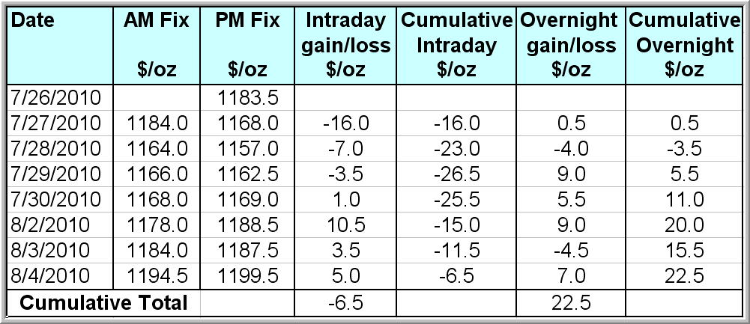
Table 1: Sample of Gold Fix Data

Figure 2 shows the cumulative gains/losses for “intraday” and “overnight” daily trades since the start of the current bull market in April 2001. This chart is astonishing. The cumulative price change between the AM Fix and the PM Fix in the last 9 years is negative $500/oz while from the PM Fix to the AM Fix it is positive $1,400/oz. What this means is that if a trader had each and every day purchased gold on the AM Fix and sold it the same day on the PM Fix he would have lost $500/oz. If he had instead bought gold every day on the PM Fix and sold it the following day on the AM Fix he would have made $1400/oz. (these calculations exclude fees and commissions). One could go further and say that if a trader had shorted gold on the AM Fix and covered the short on the PM Fix and then bought gold on the same PM Fix and sold it the following morning on the AM Fix and repeated this every day over the last 9 years the trader would have made $1,900/oz; a buy and hold strategy by comparison would have gained only $950/oz. ($250/oz gold price in 2001 to $1200/oz in 2010).

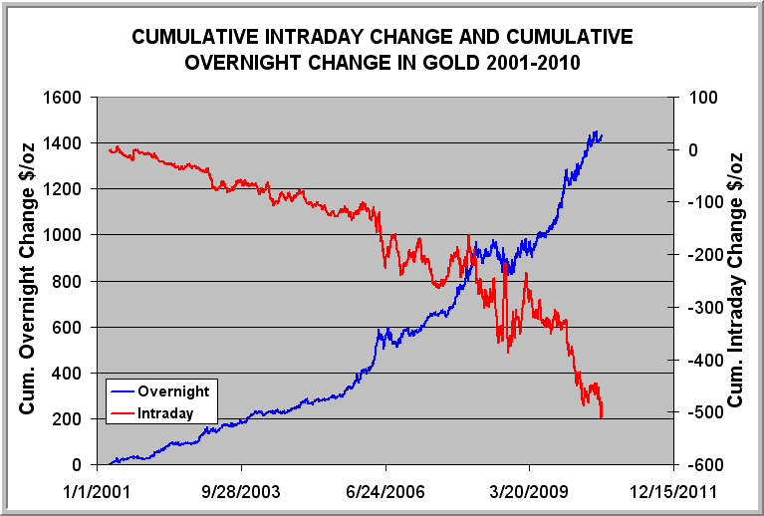
Figure 2: Cumulative Intraday Change & Overnight Change 2001-2010

The change in price between the AM Fix and the PM Fix are cumulatively making a trend which is increasingly losing money in a very strong bull market! Clearly the fixes are not being set to “clear the market” but are being manipulated to suppress the gold price. In figure 3 the same chart as figure 2 is shown but with the right-hand scale inverted.

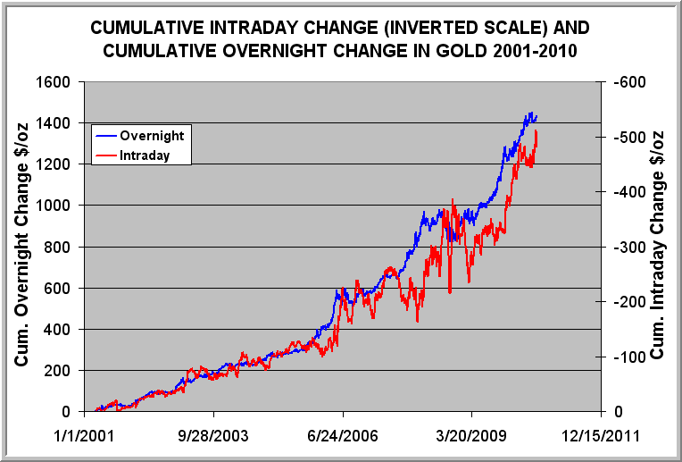
Figure 3: Same Chart as Figure 2 with Right-hand Scale Inverted

What this shows is that the more gold rises over night in essentially Asian markets the more it is sold down into the PM fix. This was exactly the modus operandum of the London Gold Pool but now it is being done covertly.

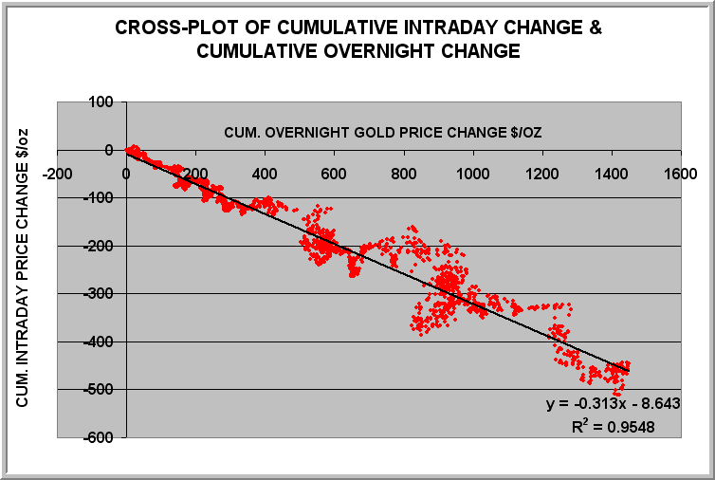
Figure 4: Cross-plot of Cumulative Intraday Gold Price Change & Cumulative Overnight Gold Price Change (2001-2010)

Figure 4 is a cross-plot of the cumulative intraday gold price change against the cumulative overnight gold price change. The chart shows that the cumulative amount that gold has declined between the AM Fix and the PM Fix at any time in the last nine years displays a linear correlation with the cumulative amount that gold has risen from the PM Fix to the following AM fix for the same period. The correlation coefficient R² is 0.95 which is very close to a perfect correlation of 1.0.

This shows that someone is consistently selling down the PM Fix and the amount of the cumulative sell down is almost perfectly linearly proportional to the cumulative amount by which gold trades up overnight. That can not happen by chance.

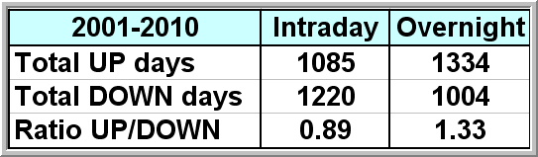
Table 2: UP & DOWN Days for Intraday & Overnight
Table 2 shows the total number of up days and down days for both the intraday and the overnight trading from 2001 to 2010. There is a striking contrast. In fact there is almost a mirror image where the number of up days overnight is very similar to the number of down days intraday. The probability of getting this contrasting result at two different times in the same 24 hour period, in the same commodity market, and over a 9 year period is approximately one in 2.6 x 10^{31.} In other words it is practically impossible for such a divergence of data to occur by chance, let alone for the divergence to have a nearly perfect correlation.

This is in fact a very sophisticated market manipulation that is conducted to minimize the chances of being noticed by a casual observer. In Table 1 it can be seen that gold is not systematically sold down the day following an overnight rise. It is programmed and executed over several days which is why it is only clearly revealed by looking at the cumulative changes over time. In figure 5 it can be seen that the AM Fix data and the PM Fix data appear to almost overlay. This is because the average difference between them is managed.

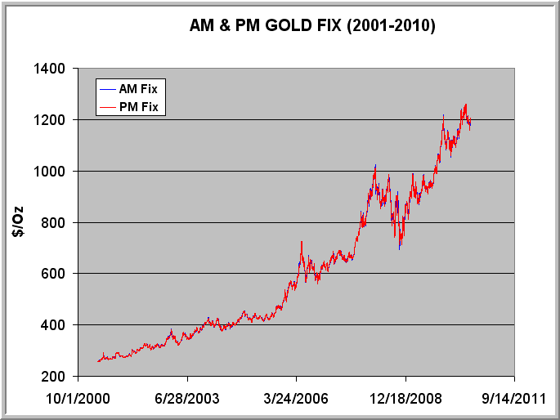
Figure 5: AM & PM Fix (2001-2010)

Figure 6 shows the daily difference between the AM Fix and the PM Fix charted as a percentage change from 2001 to 2010. It shows that a staggering 88% of the data fall in the minus one percent to plus one percent range. Equally surprising 98% of the data lie in the minus 2 percent to plus two percent range. This also can not happen by accident. The gold price has increased 400% in nine years yet the percentage daily price range between the AM and PM Fixes remains locked largely in a 1% band. This is why the AM & PM fix price data appear to overlay in figure 5 because the daily variation is tightly controlled. This could only be achieved by market interference.

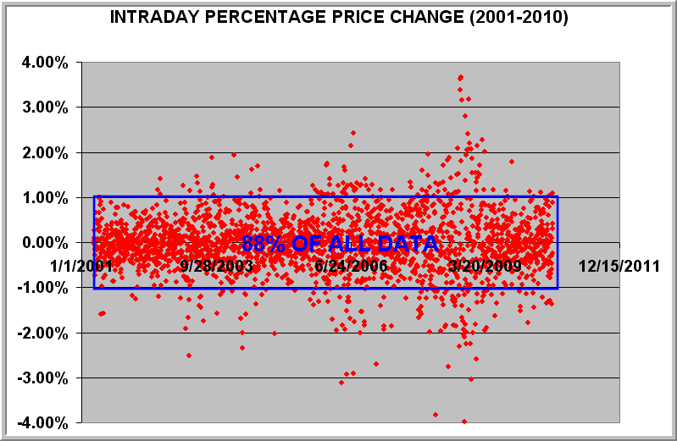
Figure 6: Intraday Percentage Price Change (2001-2010)

The inescapable conclusion is that some entity or entities are deliberately suppressing the gold price between the AM Fix and the PM Fix and that this suppression is calculated to proportionately counter the cumulative gains in price achieved in the Asian markets that trade at some time in the period after the prior day PM Fix until the following AM Fix. Such a consistent manipulative effort would necessarily involve entities with access to large amounts of gold; this implicates central banks as they are the only entities with large hoards of gold and furthermore they have a motive for suppressing the price of gold which is to hide their mismanagement and debasement of their national currencies. Furthermore the five bullion banks who conduct the Fix would have to be complicit because by definition they are responsible for determining the clearing price on the Fix so they must be aware of the impact on price of the selling activities of the entity or entities who are offering gold in such large quantities that it causes such price aberrations. As the central banks do not trade themselves it is more than likely that some or all of the banks involved in the Fix also act on behalf of Central Banks. What is irrefutable from this analysis is the gold market is not “fixed” it is “rigged”!

The suppression of the gold price is achieved in three main “theaters of war”:

1) The LBMA unallocated gold dealing is a fractional reserve operation with a reserve of probably less than 3%. This is largely a paper gold market that masquerades as a physical gold market. Palming off the unsuspecting investor with unallocated gold with a very low reserve ratio prevents the investor’s money from chasing real physical bullion which inherently acts as a price suppression mechanism (see my recent article Proof of Gold Price Suppression for more details).

2) It is important to suppress the price so that investors who insist on having physical bullion are dissuaded from thinking it is a good investment. As demonstrated in this article this is done by selling gold into the PM Fix to counter the rise in the price that occurs in the physical markets of Asia. This is exactly the same tactics as employed by the London Gold Pool of the 1960’s.

3) The large bullion banks, most notably JPMorgan Chase and HSBC, sell short on the Comex inviting other commercials to join in the short selling binge to create frequent waterfall drops that wipe out speculators and serve as a cold shower for those who are bold enough to make leveraged bets that gold prices will rise.

Additional and complementary measures include the establishment of largely unbacked Gold Exchange Traded Funds (ETF) that serve to divert demand away from the real metal. OTC derivatives that are used to hedge the essentially naked short exposure that exists by virtue of the fractional reserve nature of the massive unallocated gold market.

The London Gold Pool failed due to insufficient gold to meet demand. In those days the paper market was not as dominant. By contrast it is through selling massive amounts of paper gold that the gold cartel has managed to keep the lid on its current price suppression scheme. But therein they have unwittingly planted the seeds of their own demise. I estimate that 45 ounces of gold have been sold in unallocated accounts for every one ounce that exists in the vaults. When just a fraction of these investors ask for their gold there will be a run on the bullion banks of epic proportions. When 45 claims go looking for one ounce of physical gold the rise in bullion prices will be breathtaking.

If you own unallocated bullion you likely only have a claim to about 2.3% of what you think you own. The window of opportunity to get your investment to be 100% bullion is closing rapidly.

This article has shown that physical gold is being dumped into the PM Fix to contain its price in a covert version of the 1960’s London Gold Pool. The result of the failure of the London Gold Pool to suppress gold was an appreciation of the gold price from $35/oz to $850/oz; a similar percentage today would carry gold to almost $30,000/oz. This is not a price forecast but an indication that when free market forces have been frustrated by market manipulation for a very long time the equilibrium price can be many multiples of the suppressed price and the rise is typically rapid when the suppression is overcome. There are many growing signs that suggest the gold manipulation scheme is coming unraveled. The onset of an epic “gold rush” is fast approaching.

Adrian Douglas
Editor of Market Force Analysis
Board Member of GATA

August 10, 2010

www.marketforceanalysis.com
Market Force Analysis is a unique analysis method which provides reliable indications of market turning points and when is a good time to enter, take some profits or exit a market. Subscribers receive bi-weekly bulletins on the markets to which they subscribe.

