New Year’s Day, 2014

2015 Trade of the Year

“pos·tu·late “(verb)

Definition: “suggest or assume the existence, fact, or truth of
(something) as a basis for reasoning, discussion, or belief”

Foreword:

This time last year, I constructed the 2014 Trade of the Year, in which I postulated that after thirty months of weakness in the precious metals markets (physical and shares) that precious metals were due for a recovery. I also postulated that the S&P500, after fifty-four months without a significant correction, would underperform gold as mean reversion would kick in. I recommended the purchase of the GDX (Senior Gold Miners’ ETF) at $23 and the sale of the SPY (S&P500 ETF) at $180 for a net short of around $157.

How did that work out?

I was stopped out of the SPY at $190 (Whew!) for a loss of 12% and as of the close last Friday, the GDX was down 13.21%. Despite a terrific performance in the first half of 2014, the trade ended badly.

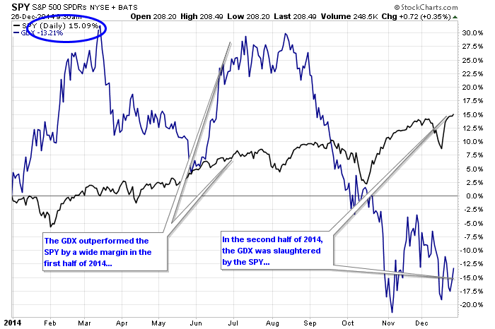

The “LMSSP” started out great but ended very badly

Why did the trade falter in the second half of 2014?

Let’s start off with the definition of the word “postulate”. It is defined as “to suggest or assume the existence, fact, or truth of (something) as a basis for reasoning, discussion, or belief”. I “postulated” that the Gold Miners would normalise in terms of valuation and that the U.S. stock markets would do the same. I “suggested or assumed” that free markets would be allowed to return and values would be once again based upon the “existence, fact, or truth” of HONEST price discovery.

Honest price discovery? Let’s start with a look at the SPY. The zero-interest-rate-policy (“ZIRP”) of the global central banks has herded money from the bond market into the stock market both indirectly (“QE” bond buying) and directly (Direct central bank buying of stocks). The net result is that historical securities analysis has to be thrown out the window because even garbage stocks (like IBM) are supported by corporate buybacks fueled by cheap and easy money (ZIRP).

Oh, and how about interventions? All you need to do is take a glance at the chart of the S&P500. Notice how the price was managed higher after the major correction in late 2011. It was if someone drew the chart going out to 2015 and told the New York Fed’s trading desk to “Make it so”.

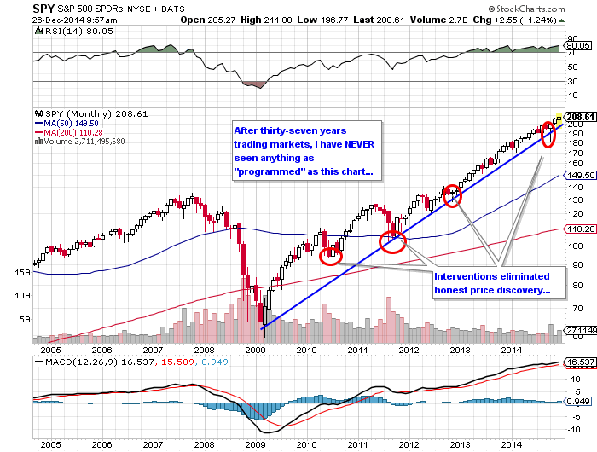

Now let’s look at the gold price. The chart included below has to be viewed with astonishment. Despite the greatest physical offtake of the metal in history, the U.S.-dollar-denominated price of gold declined. The interventions began at the all-important $1,525 support level in 2013 when unnaturally-large amounts of gold futures (“synthetic gold”) were dumped into the Comex with zero regard for “best price” and total regard for the $1,525 support level being shattered. These interventions have occurred at every critical chart point in the same way that every decline in the SPY was rejected at major price points (<10% decline).

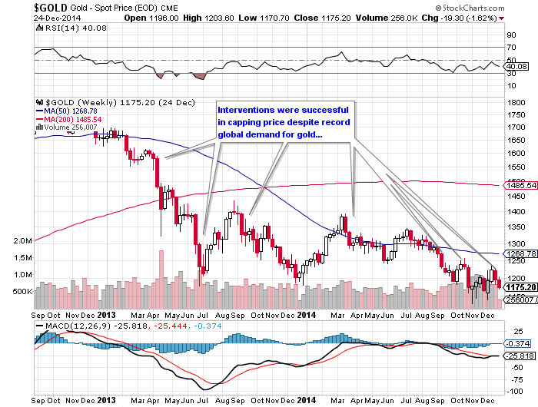

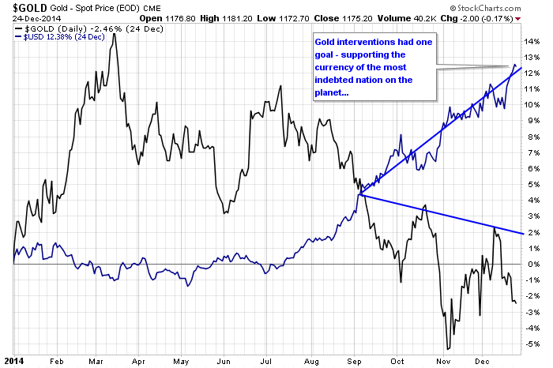

The key question for 2015 has to once again address the one question – the ONLY question – that matters and that question is “What will force the markets back to “honest price discovery”?” – and that is applied not just to gold or silver or oil or stocks; it also applied to determining the proper rate of “risk-free return” (or as Jim Grant refers to it, “return-free risk”) that is historically found in sovereign debt (bonds). As recent events in Russia have illustrated, when panics set in, the so-called “safety” in the Russian bonds was obliterated by the currency collapse as sanctions (interventions) sent the ruble down 60% versus the U.S. dollar. Now consider this: the debt/GDP level for the United States is 120%; for Russia, it’s 12%. The ruble is being covertly backed by gold based on recent disclosures of Russian gold purchases yet the global markets have pegged U.S. Treasuries as being “safer” than Russian sovereign debt. This is proof-positive that through the power of the financial press, the Emperor State has convinced the world that it has a magnificent robe on while we the seekers of honest price discovery are desperately awaiting the child in the crowd that postulates – assumes the existence, fact, or truth – that such robe is actually not there and that the Emperor is indeed naked.

2015 Trade of the Year

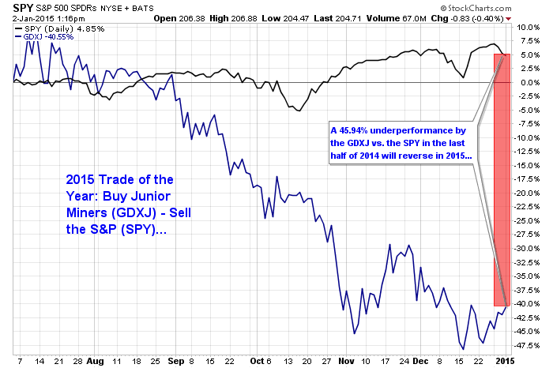

For reasons mentioned above, I am once again going to initiate the same trade for 2015 that I offered in 2014 with a minor revision. The junior gold mining stocks contain greater sensitivity to the decompression of value in both the gold price and traditional methods of securities analysis such as price-to-free-cash-flow, price-to-book, and market-cap-per-ounce-in-reserve. I am therefore going to replace the Senior Gold ETF (“GDX”) with the Market Vectors Junior Gold Miners ETF (“GDXJ”) buying @ $23.50 while selling short the SPDR S&P500 ETF Trust (“SPY”) @ $208.50. I am effectively shorting the spread at $185. Another way to limit losses on the S&P500 is to use the SPY June $195 puts in the $6.00-7.00 range as a replacement for an outright short on the SPY. For purposes related to this recommendation, I will be personally going long 4000 GDXJ at $23.50 ($94,000) while buying 20 contracts @ $7.00 ($14,000) for total dollars invested of $108,000.

I am reminded of the old adage surrounding the “hands of a broken clock being right twice a day” and that Einstein’s definition of insanity which is “doing the same thing over and over and expecting different results”. However, I am also reminded that the Fed has a targeted inflation rate of 2% and at last glance, U.S. inflation was running at around 1.3% and that was before oil went into its swan dive from $90 to $53 in the last quarter of 2014.

It is my belief that policy change is coming to the world of the Central Bank price managers. If you believe as I do that bankers fear deflation far more than they do inflation, these price managers cannot let the consumer begin to hoard cash in expectation of lower prices ahead. Deflation makes debt servicing nearly impossible and it lowers the collateral value of the debt, which is the nuclear bomb in the big bank portfolios. Led by the U.S. Fed, they must exercise the utmost in “behavioural finance” in order to prevent deflationary expectations from escalating.

Now, since 2009, the Fed has increased its balance sheet through brazen money-printing to a mind-boggling $4.1 TRILLION. In order to accomplish this incredible feat, they had to keep a handle on inflationary expectations. Just as Paul Volcker admitted in the 1980’s, the mistake that was made during that 1970-1980 money-printing orgy was that “we should have kept a lid on the gold price”. This time around, between Greenspan, Bernanke, and Yellen, gold’s historical role as the fiscal canary in the monetary policy coal mine was completely suppressed through interventions. Inflationary expectations were “managed” by rendering the barometer useless by way of the sale of millions upon millions of ounces of synthetic (i.e. “counterfeit”) gold and silver via the Comex. Fixed income managers flooded into bonds of all grades and durations because the stated inflation rate appeared to be “subdued” and what was the proof of “No Inflation”? Why, the price of gold and silver, of course!

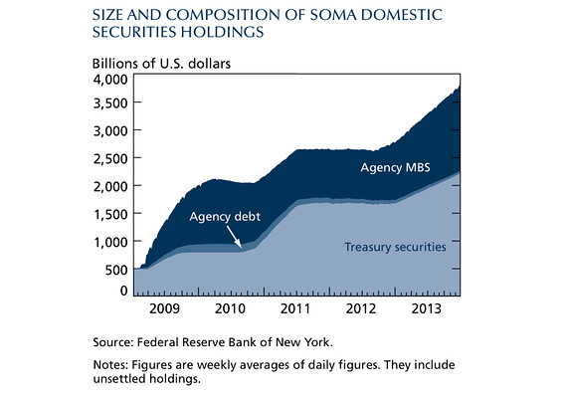

Central Bank Policy: Why the anti-gold strategy must and will change

My current thinking is that 2015 will usher in a new policy mandate for the global CB’s in much the same manner in which Japan recently shifted gears and began to proactively manufacture inflation to combat the Great Deflation that had plagued that nation since the 1990’s. The Western bankers will have to prevent deflationary expectations from becoming engrained into the mindset and behaviour of the consumer and in order to do that, they will come out with phony statistics that will denounce “deflationary trends” but to show evidence of that, they will have to change policy on gold and silver pricing. Up until the end of 2014, the evidence of “contained inflation” has been declining gold and silver prices but now that oil and copper have joined the “crash mode” parade, bankers are starting to feel the heat in their resource-related loan portfolios. For this reason and this reason alone, I look to 2015 being the year that the Fed and its G20 brethren began to “embrace” rising gold and silver prices as being “good” for the banking business. Rising gold and silver prices give them “cover” for being able to talk the “Everything is fine” mantra through their mainstream media minions.

Going back to the chart of the S&P500, the management of the S&P500 has at its roots the heart of behavioural finance in that ever since the 1982 Great Bull Market in stocks began, the MSM has chortled and hypothecated about the “wealth effect” associated with rising stock markets. After the Great Financial Crisis of 2008, the global central bankers needed to make people BELIEVE that things were getting better so no better way than to use the S&P500 as “proof”. In 2015, the central bankers will be using the gold and silver prices as “proof” that “deflation is contained”. If they are successful (and it is a huge “IF”), real estate, stocks, and commodities will all have a banner year. If they are not successful in threading this fiscal and monetary policy needle, the only safe haven will be lots of currency (cash) and the safest currency on the planet is what?

Say no more of this barbarous relic…Enjoy the encore performance of the “Long Junior Miners/Short S&P500” Trade of the Year (and if it doesn’t work out this year, look for a repeat again in 2016).

MJB

Michael J. Ballanger B.Sc.,B.A.
Email: mballanger@rogers.com
Tel: 416.786.5055

