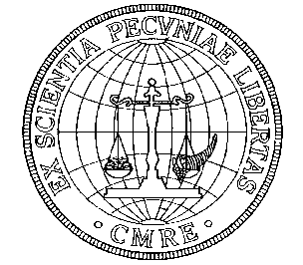
COMMITTEE FOR MONETARY RESEARCH & EDUCATION, INC.
Annual Fall Meeting Thursday, October 20, 2011
The Union League Club 38 E. 37th Street, New York City

Uncle Sam: Desperately Seeking Money
A powerful program with speakers covering conditions in the China, Europe, Great Britain, the United States, with a conclusion on what the US must do.

From Singapore: James Rogers with his views of China and the US.
A special exchange with Jim via Skype.

From Europe: Robert Mundell famous creator of the Euro, what comes next?

From Great Britain: Alasdair Macleod with more of his London GATA
Speech, “Beyond the Tipping Point,” from his articles, “Keynes vs Hayek” and
“2011 – The year when money starts to die.”

From the United States: Read “Reckless Endangerment”
Co-authors Gretchen Morganson and Joshua Rosner
Josh Rosner on the American market of 2008, the steepest downturn since the Great Depression, called the worst financial calamity of modern time.

Walker Todd, CMRE Director, Read CMRE Monograph No. 51, “From
“Constitutional Republic to Corporate State: The Federal Reserve Board
1931-1934” (Order from CMRE)

America’s Outlook
Lewis E. Lehrman, Founder of the Lehrman Institute, Gold Standard US.
The Need for Money of the Constitution

Prof. Thomas Rustici, Professor of Economics and Economic History, George Mason University- his understanding of money draws crowded class rooms.

Dr. Edwin Vieira author of the major books on Money and Law – basis for his reputation as the sage of monetary education.
Both Prof. Rustici and Dr. Vieira have received standing ovations.

Chris Powell Secretary Treasurer of Gold Anti-Trust Action Committee, Managing Editor, Journal Inquirer, Manchester, CT.
Answers the question: Where in the world is the gold?

Early Reservations by Mail Recommended – Registration and Gathering begin at 4:00 PM Oct. 20. / Contact: Elizabeth Currier, email: CMRE@bellsouth.net
10004 Greenwood Court, Charlotte, NC 28215 704-598-3717

