The Failure of the Second London Gold Pool

By Adrian Douglas

This article is a sequel to my article entitled “Gold Market is not “Fixed”, it’s Rigged” which is essential reading before reading this article. The previous article demonstrated that had a trader consistently bought gold on the London AM Fix and sold it the same day on the London PM Fix and repeated it every day from April 2001 through to today the cumulative loss would be $500 per ounce. Yet gold has been in a bull market during that time and a “buy and hold” strategy over the same time period would have returned a gain of $950 per ounce.

I have termed the arithmetic difference between the PM Fix and the AM Fix the “intraday change.” Figure 1 shows the evolution of the cumulative intraday change from 2001 to 2010 along with the gold price evolution as expressed by the London PM Fix price.

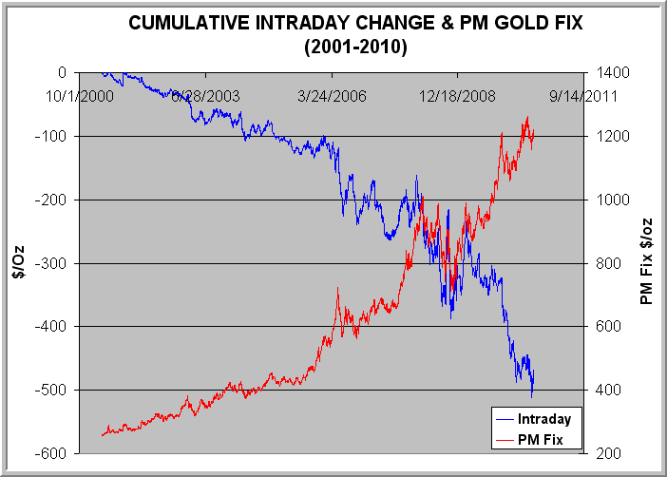
Figure 1 Cumulative Intraday Change & PM Gold Fix Price (2001-2010)

This chart shows that an entity (or more likely several entities) is consistently selling gold into the PM Fix in such large quantities that the selling suppresses the gold price to the extent that the cumulative intraday change is negative while the gold price has been increasing. The entity doing such selling must have access to a large amount of physical gold and must not be interested in selling for profit. The only possible culprit is a central bank or several central banks. As the central banks do not trade directly, there must be bullion banks who are acting on their behalf.

The London Gold Fix is conducted by the representatives of five bullion banks: HSBC, Deutsche Bank, Scotia Mocatta, Societe Generale, and Barclays. The “fix” is no longer conducted in an actual meeting but by conference call. The bullion banks’ representatives communicate with their trading floors and with each other during the conference call to find the clearing price at which all buying interest and all selling interest is balanced. When this price is determined the price is said to be “fixed”. This is exclusively a physical gold market activity. It is balancing the number of bars of gold for sale with the number of bars demanded for purchase at a particular price.

It follows that if buying and selling were matched at the AM Fix price but then the PM Fix price is lower, then significantly more gold is being offered for sale compared to demand at the time of the PM fixing. The trend of the cumulative intraday change in Figure 1 shows that the selling into the PM Fix is manipulative because it has consistently countered the primary trend of the market and has proportionately increased as the gold price has increased. The PM Fix is the target for manipulation (price suppression in this case) because it stands as the global bench mark price at which physical gold trading is done until the following AM Fix, -- that is, a period of 19 ½ hours each day.

Though the official London Gold Pool disbanded in 1968 when it suffered massive outflows of bullion trying to frustrate free market forces that were manifesting themselves as insatiable demand for the metal, someone is now operating, albeit covertly, a second London Gold Pool. However, what I will show unequivocally in this article is that this “Second London Gold Pool” is about to suffer the exact same fate as the first one did.

.

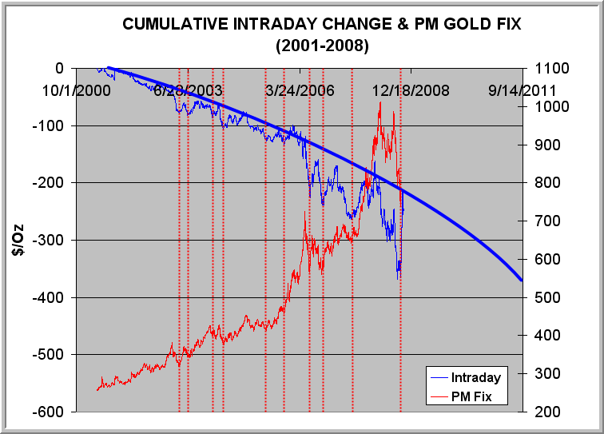
Figure 2 Peaks Marking Climax of Increased Selling into the PM Fix

In figure 2 the same data as in Figure 1 is presented except it has been truncated to October 2008. The solid blue line shows that there is a long-term trend in the evolution of the intraday price change that is responsible for the general suppression of the price. However, what is also apparent is that there are many occurrences of the cumulative intraday price change deviating downward from this baseline trend and returning back to the trend. These are periods of concerted and increased dumping of gold into the PM fix. The red vertical lines mark the turning points of maximum departure of the cumulative intraday price change from the solid blue line that defines the average long-term trend. In other words, these lines mark the climax of selling into the PM Fix. It can be noted that these lines intersect the PM Fix price curve at almost exactly the lows immediately following a price peak. This means that when the intensity of selling into the PM Fix increases (an increasing downward excursion of the blue curve away from its trend line), the gold price makes an intermediate top, and when the intensity of selling into the PM Fix recedes (the blue curve returns toward its trend line), the gold price makes a bottom.

This is not a matter of traders selling into the market to take profits when the price reaches an interim top, because the selling is consistently forcing the PM Fix price to be lower than the AM Fix even during price rallies. The selling is clearly conducted such that when considered over several days buying between the fixes is not allowed to be more dominant than selling. It can be seen that after each selling climax buying emerges which carries the cumulative intraday change back toward its long-term negative trend line (solid blue line). I would speculate that at least part of this buying is made by the same entities that did the selling.

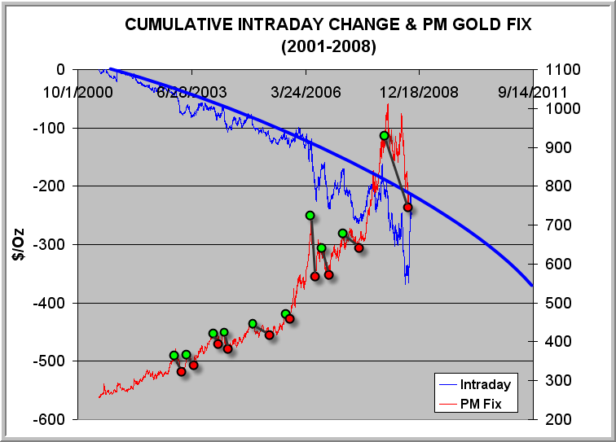
Figure 3 Gold Price Declines Induced by Increased Selling into the PM Fix (2001-2008)

Figure 3 shows how each episode of increased selling into the PM Fix had the desired results for the central banks and the anti-gold cartel of bullion banks: The gold price declined from the green dot to the corresponding red dot.

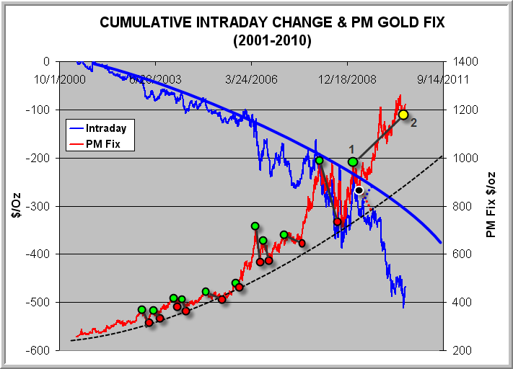
Figure 4 Gold Price Declines Induced by Increased Selling into the PM Fix (2001-2010)

In Figure 4 the data from October 2008 to August 2010 has been added. The gold price peaked on 2/20/2009, marked by the green dot labeled “1”. True to form massive selling then emerged in the PM Fix on a continual basis. The intent was probably to make the gold price decline along the trajectory indicated by the red dashed line to suppress it back to the long-term trend defined by the black dashed line. The cumulative intraday price change would then have most likely returned to the long-term trend line (solid blue line) on a trajectory indicated by the blue dashed line.

But things have gone horribly wrong for the manipulators. The gold price did initially decline to the point marked by a black dot, which occurred on 4/24/2009; but then the gold price abruptly reversed upward. As a consequence the manipulators ramped up their dumping of gold into the PM Fix as shown by the plunging cumulative intraday price change.

This has continued for 16 months and the gold price has stubbornly resisted these attempts to overwhelm free market forces of strong physical gold buying. To date the climax of the selling into the PM Fix occurred on July 28, 2010 and the gold price on that date is marked by the yellow dot and labeled “2”. It is $220 higher than the point “1”, where increased selling into the PM Fix commenced.

This is the first time in nine years that the cycle of increased selling of gold into the PM Fix has failed to bring down the price of gold. The arrogant central bankers and their bullion banking cronies are reliving their nightmare from the London Gold Pool of 1960’s, where they erroneously thought they could out-gun free market forces.

What is intriguing is what happened on 4/24/2009, the date marked with a black dot, which unleashed massive new physical demand that has overwhelmed the scheming Western central banks. On April 24, 2009, China announced that it had accumulated 454 tonnes of gold over the previous five years, bringing its reserves to 1,054 tonnes. China had instantly let the genie out of the bottle. If China had been acquiring gold secretly for five years, then every other central bank and large investor was behind the curve. Serious buying immediately appeared but this was clearly buying by a very different type of buyer. These buyers are not only insensitive to the anti-gold cartel’s intimidation tactics of dumping gold to suppress the price but they actually welcome it as it allows them to buy more gold at discounted prices.

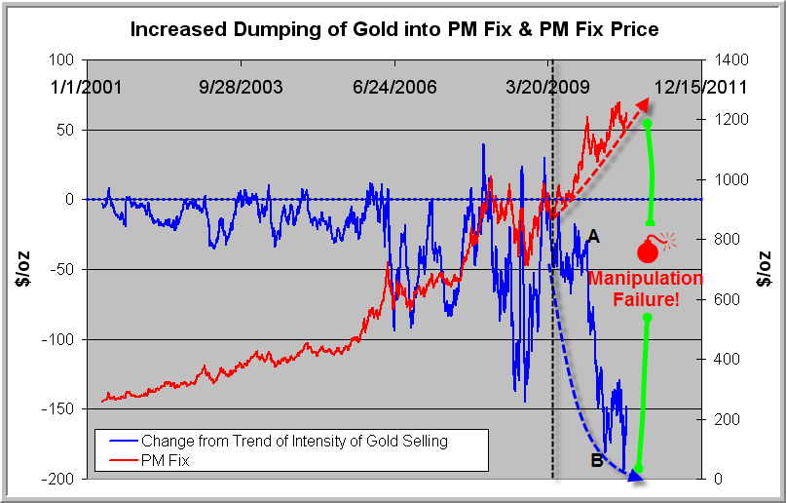
Figure 5 Gold price Suppression is Failing

In Figure 4 the solid blue line trend indicates that there is a continuous “background” suppression of the gold price that drives down the PM Fix with respect to the AM Fix. In addition there are periods of increased selling activity that cause the cumulative intraday price change to deviate below the solid blue line trend. In Figure 5 the blue curve represents only the deviation from the declining trend. This means that the curve represents periods of increased intensity of selling into the PM Fix. The baseline is the dashed horizontal blue zero line which means that at that level the suppression of the gold price is uniform and corresponds to the data following the solid blue trend line of Figure 4. The downside excursions from the horizontal indicates periods of panic dumping into the PM Fix that coincide with “flare ups” in the gold price. Once the manipulation has succeeded in knocking back the gold price to what is presumably a more acceptable rate of ascent for the manipulators, the blue curve returns to the zero level again.

However, it is clear from the chart that since 4/24/2009 (marked with a vertical dashed black line) the anti-gold cartel has entered a new phase. It is their equivalent of “Houston, we have a problem.” And do they ever! They have ramped up their dumping of gold into the PM Fix to a level that exceeds even what was dumped to bring down the price in 2008, but the gold price refuses to yield. Judging by the way the market was managed until 2009, if the gold price could be brought back into line, it would already have been done.

The fuse is lit. This is a covert London Gold Pool that is about to fail as catastrophically as its predecessor did in 1968.

Notice how large and aggressive the selling of gold into the PM Fix was between the points marked by “A” and “B” in Figure 5. This corresponds to a period from 12/2/2009 to 3/30/2010. The bullion banks would need a lot of extra bullion to conduct such an attempted “shock and awe” bombing of the gold market.

Where did this gold come from?

I wrote an article recently entitled “gold manipulation scheme is coming unraveled”. This article discussed how 346 tonnes of gold that were part of a hushed-up swap arrangement between the Bank for International Settlements (BIS) and more than ten bullion banks were essentially a bail-out for the bullion banks concerned. We now know why these banks desperately needed such a vast amount of gold. Together with approximately 15 tonnes of gold being sold surreptitiously by the International Monetary Fund (IMF) each month since February this year, it is new ammunition in the war they are waging on the gold price.

The BIS gold swap occurred in the first three month of 2010 which falls in the period marked by “A” and “B” in Figure 5. The evidence of significantly increased dumping of gold that coincides with the timing of the BIS gold swap (the largest in history) is damming, to say the least. However, the mobilization of this gold is futile. When anything in a market goes parabolic, it is unsustainable. The bullion banks on behalf of their Western central bank masters are dumping gold into the PM Fix at such a rate that the cumulative daily price change between the AM Fix and the PM Fix is becoming more and more negative in a parabolic blow-off.

It looks like the demise of the gold price suppression scheme is very close at hand. Over the years GATA has uncovered a lot of anecdotal and circumstantial evidence that the Western central banks have been dishoarding gold at an unsustainable rate in order to suppress the price. This is the first concrete evidence that, just as GATA has long been predicting, the gold price is set to blow up because physical demand for gold is overwhelming the manipulators’ ability, or willingness, to provide it.

The result of the 1968 failure of the London Gold Pool to suppress gold was an appreciation of the gold price from $35 to $850 per ounce. A similar percentage today would carry gold to almost $30,000 per ounce. This is not a price forecast but an indication that when free market forces have been frustrated by market manipulation for a very long time, the equilibrium price can be many multiples of the suppressed price, and the rise is typically rapid when the suppression is overcome.

The opportunity to acquire bullion before prices go dramatically higher is disappearing fast.

Adrian Douglas
Editor of Market Force Analysis
Board Member of GATA

August 18, 2010

www.marketforceanalysis.com
Market Force Analysis is a unique analysis method which provides reliable indications of market turning points and when is a good time to enter, take some profits or exit a market. Subscribers receive bi-weekly bulletins on the markets to which they subscribe.

